Parking Structure Management System
(PSMS)

Requirements Definition Document

RDD Version 4.0

Team T01
29 January 2026

Beckett Dunlavy (manager)
Aditya Chauhan
Christian Maestas
Oscar McCoy
Isaac Tapia

CS 460 Software Engineering
Table of Contents

1 Introduction 3
2 Definition of Terms 4
3 Objectives 4
4 System Organization 5
5 Interfaces 10
5.1 System Inputs 10
5.2 System Outputs 11
6 Capabilities 12
7 System Constraints 13
8 Conclusion 16
9 References 17

1 Introduction
Parking structures provide concentrated parking capacity for high-demand areas such as campuses and urban centers. For such facilities to operate effectively, the system responsible for admission control and availability reporting must maintain a consistent and accurate representation of occupancy across multiple floors. In practice, availability is affected not only by vehicles occupying parking spots, but also by vehicles that have entered the structure and are traveling to locate a spot. If these intermediate conditions are not represented in the system state, the structure may admit vehicles beyond practical capacity or display incorrect availability, leading to congestion and degraded user experience.
This Requirements Definition Document (RDD) specifies the requirements for the Parking Structure Management System (PSMS). PSMS is a software-controlled system for managing a multistory parking facility that maintains floor-level and structure-level occupancy and capacity information using sensor inputs and defined vehicle state transitions. PSMS shall model two vehicle states: In Transit, and Parked. PSMS shall also model spot-status indicators using red/green/blue lights to represent occupied, available, and handicap availability. The system shall support controlled entry through an entry gate that permits admission only when the structure is below maximum capacity, and it shall support an exit gate that permits unrestricted exit flow.
This document defines the system scope, terminology, objectives, high-level organization, required capabilities, and system constraints of the PSMS. The scope of PSMS excludes payment processing, license-plate recognition, and identity-based enforcement mechanisms. Where implementation choices exist (e.g., selection of sensor types and emergency behavior under power loss), this RDD constrains the system through stated assumptions and required behaviors, while leaving implementation details to later design artifacts.
The remainder of this document is organized as follows. Section 2 defines the terms used throughout this RDD. Section 3 describes the objectives that guide the system requirements. Section 4 presents the high-level system organization and information flow. Section 5 describes the system interfaces. Section 6 specifies the required system capabilities grouped by entry/exit management, occupancy and sensor behavior, real-time information displays, and emergency handling. Section 7 documents system constraints and assumptions. Sections 8 and 9 provide a conclusion and list references, respectively.

2 Definition of Terms
- ADA (Americans with Disabilities Act): Federal legislation that mandates specific design standards for accessible parking, including stall width and signage.
- Aisle: The driving path within the parking structure used for vehicle circulation between parking stalls.
- Binary Sensor: A hardware device installed in a parking spot that reports one of two states: occupied or free.
- DPM (Development Process Manual): The City of Albuquerque’s regulatory document that defines standard dimensions for parking infrastructure.
- Egress: The action of leaving the parking structure, specifically prioritized during emergency scenarios.
- Fail-Safe: A design feature that ensures the system defaults to a safe state (e.g., closing entrance gates) in the event of a power or software failure.
- Floor-Level Capacity: The maximum number of vehicles permitted on a specific level of the structure, determined by the total number of physical parking stalls available on that floor.
- Internal State: The software’s real-time "memory" or count of occupied spots and admitted vehicles.
- In-Transit: A core vehicle state representing a vehicle that has passed through an entry gate but has not yet been detected by a parking sensor. This is a software-calculated value derived from the difference between the gate transactions and occupied spots.
- PSMS (Parking Structure Management System): The complete software and hardware control system responsible for tracking capacity and vehicle flow.
- Stall: An individual designated area within the parking structure intended for the parking of a single vehicle.
- Structure-Level Capacity: The total maximum occupancy of the entire facility. This value is used to trigger “Full” status at entry gates and is the sum of all Floor-Level Capacities.
- Van Accessible: A specific type of ADA parking space that includes a wider access aisle to accommodate wheelchair lifts.

3 Objectives

The primary goal of the Parking Structure Management System (PSMS) is to develop a comprehensive system that mitigates the congestion and inaccuracy issues often found in high-demand parking facilities, as it can be a very frustrating experience for users if they end up driving in circles, lost in the parking structure. By distinguishing between parked vehicles and those currently in transit, the system aims to close the gap between actual and reported availability, ensuring that admission to the structures is based on real-time capacity. This kind of parking structure is one that will make the experience of parking quick and easy for those using it.
The specific objectives for the development of the PSMS are:
- Maintain Real-Time Occupancy Accuracy: Ensure the system maintains a single, consistent count of vehicles in the structure (Parked + In-Transit) so admission control never exceeds capacity.
- Ensure Operational Safety: Prioritize user physical safety in the facility by enforcing fail-safe states and unrestricted departure protocols during power failures or emergency events.
- Optimize User Decision Making: Provide transparent, real-time feedback to drivers regarding capacity and spot availability, allowing users to make informed decisions before and during their time in the structure to minimize search time.

4 System Organization

This section provides an overview of the system organization for the Parking Structure Management System (PSMS) used to manage the operation of the multi-level parking garage. The PSMS is designed to detect parking availability, monitor vehicle movement, and control overall access to the structure in real time. It assumes a free parking structure; payment/ticketing is not part of the system and is out of scope. When a vehicle is detected at the entrance lane by an entry sensor, PSMS registers an entry attempt. On entering the system, the vehicle will be in one of two states: In Transit (inside the structure but not yet parked), or Parked. Using a network of sensors at the gates and each parking spot, the PSMS stores data about parking availability and overall vehicle presence. The information is processed internally, and the output produced contains valuable information such as parking counts per floor, gate control signals, and sensors above each spot to distinguish available from unavailable. Prior to showing the black box diagram, we present an overview of the parking structure and its components.

Figure 1 maps out the structure of the parking garage and the different components that are in play. Cars change floors by using ramps designated in the figure. The figure gives a visual representation of what the parking structure will look like. Exit is on the rear of the structure.

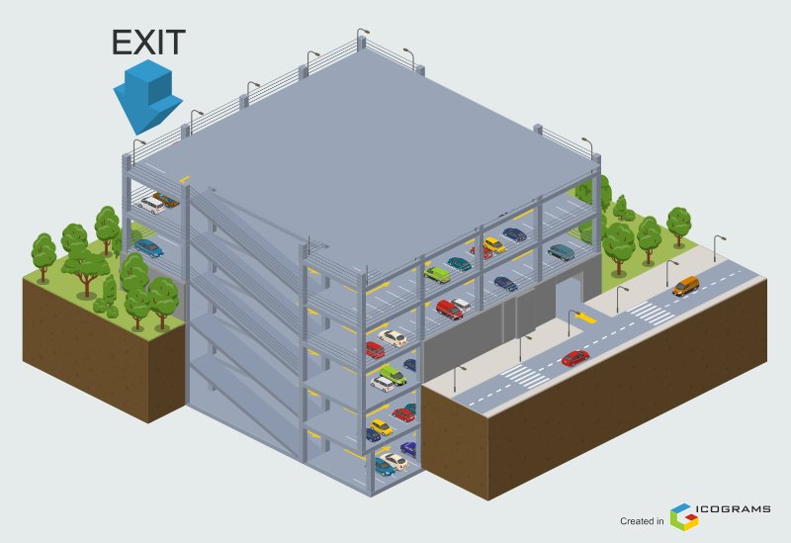
Figure 1: Parking Structure Overview [6]

Figures 2 & 3 show a visual representation of the entrance and exit gates, the only ways to get in and out of the structure. This figure gives the reader a point of view on what driving up to the structure would be like in person.

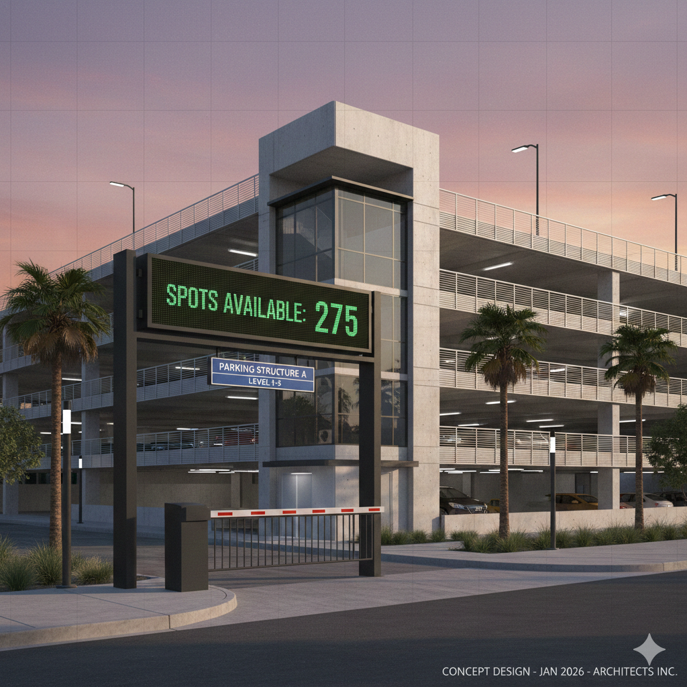
Figure 2: Entrance Overview [4]
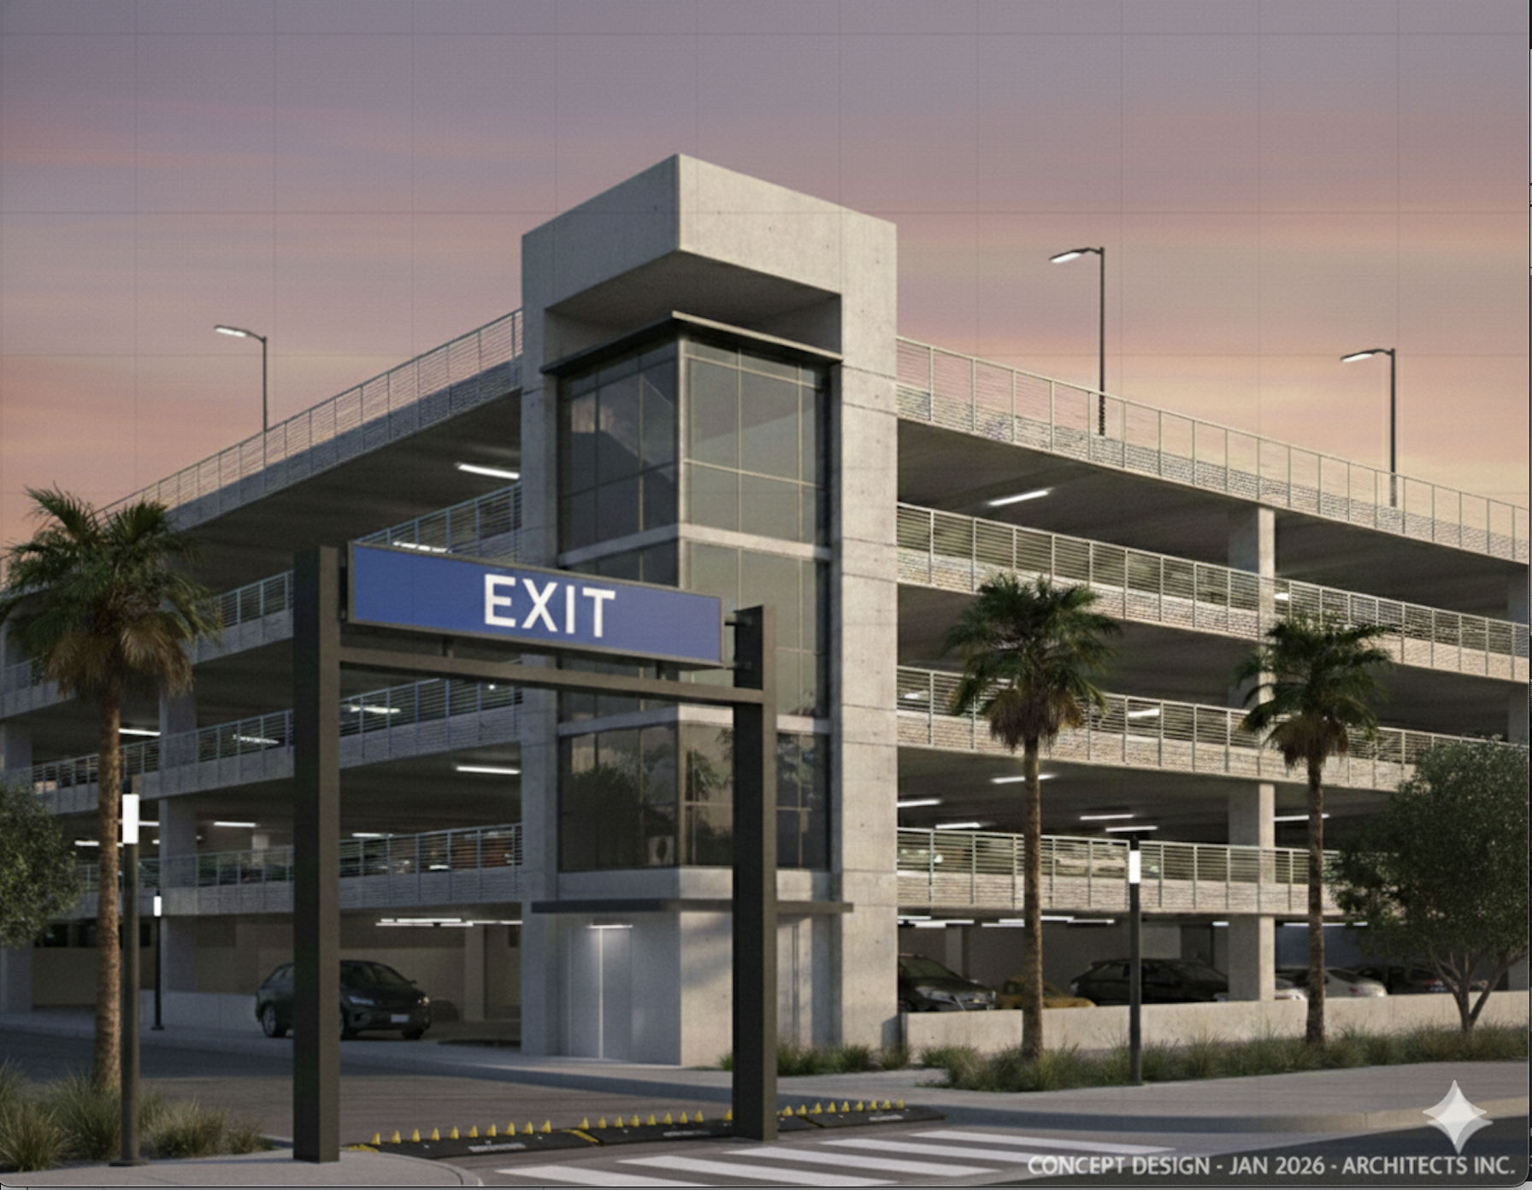
Figure 3: Exit Overview [4]

Figure 4 shows what a user of the structure will see once inside. The reader will have a visual gauge of how parking will look once they have gained access to the structure.

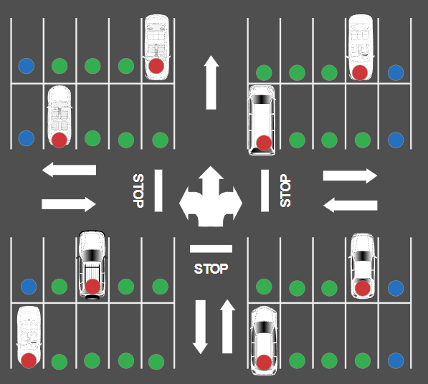
Figure 4: Floorplan and Parking Spots [5]

The black box diagram in Figure 5 displays the inputs and outputs that the PSMS will need to handle. The software will need to be able to process signals at the entrance and exit gates to allow users in and out of the structure, as well as sensors above each parking space to determine parking availability. After interpreting these inputs, the PSMS will generate an output that will determine if another car is allowed into the structure based on an internal count of parked cars and cars in transit, and turn on emergency protocols in case of power outages. Lastly, all the information sent to the PSMS will be displayed at the entrance for an overall count of remaining spots available in the garage, as well as individual floor counts to help users get on the floor with available parking spaces.

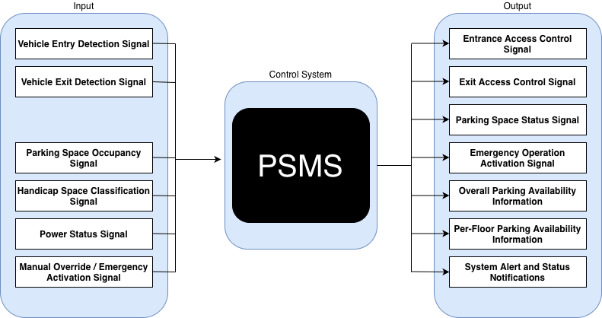
Figure 5: Black Box Diagram

5 Interfaces
This section describes the inputs and outputs that make up the interfaces of the Parking Structure Management System.

5.1 System Inputs
The devices described in this section represent the inputs that our system will use.

Vehicle Entry Detection Signal
Source Device: Entry Gate Sensor
The vehicle entry detection signal is produced when a vehicle is detected at the entrance of our parking structure. This signal notifies the PSMS that a vehicle has arrived and is requesting access to the parking structure, and will be registered to the “In Transit” state if granted access.

Vehicle Exit Detection Signal
Source Device: Exit Gate Sensor
The vehicle exit detection signal is produced when a vehicle is detected leaving our parking structure. This signal tells the PSMS that a vehicle has exited the system and, in turn, allows all internal counts of “Parked” and “In Transit” vehicles to be updated correctly.

Parking Space Occupancy Signal
Source Device: Binary Spot Sensor
The parking space occupancy signal indicates that the state of an individual parking space is either “Occupied” or “Available.” This signal is used to determine parking availability to future users, updating accurate counts per floor, and controlling overall parking space status indications.

Handicap Space Classification Signal
Source Device: Binary Spot Sensor (ADA-designated)
The handicap space classification signal acknowledges and identifies which parking spaces are designated as handicap parking only. This signal allows the PSMS to add special status indicators and help ensure accurate reporting of handicap space available on a per-spot basis (count not displayed on the parking availability screens).

Power Status Signal
Source Device: Power Monitoring Unit
The power status signal reports the functionality of the garage’s power supply. If there happens to be a power failure or an abnormal condition, this signal’s purpose is to allow the PSMS to start emergency protocols and maintain system safety.

Manual Override / Emergency Activation Signal
Source Device: Control Panel (Authorized Personnel)
The manual override and emergency activation signal allow authorized personnel to place our parking structure into an emergency or maintenance mode. This signal may be allowed to override normal system behavior to ensure safety and accessibility.

5.2 System Outputs
The components described in this section will represent the outputs from our system.

Entrance Access Control Signal
Destination Device: Entrance Gate Actuators
The entrance access control signal determines if vehicles are permitted to enter our parking structure. This output signal is based on the current structure’s capacity, parked vehicle count, and vehicles in transit.

Exit Access Control Signal
Destination Device: Exit Gate Actuators
The exit access control signal detects when vehicles exit the parking structure. This output signal operates without the capacity restrictions and ensures smooth and efficient vehicle departure from the parking structure. This signal also allows internal counts to be updated accurately.

Parking Space Status Indication
Destination Device: Parking Space Status Indicator
The parking space status indication communicates the current state of each parking spot, which includes available, occupied, and handicap status. This output signal enables the visual representation of the parking availability throughout each floor of the parking structure.

Emergency Operation Activation Signal
Destination Device: Emergency System and Lighting
The emergency operation activation signal initiates emergency behavior within the system during occurrences of power outages or unsafe conditions. This includes activating emergency lighting behavior and restricting normal system operation by not allowing any new vehicles into the structure.

Overall Parking Availability Information
The overall parking availability information communicates the total number of available parking spaces in the parking structure. This output is intended to provide the drivers with information before entering the parking structure.

Per-Floor Parking Availability Information
The per-floor parking availability information communicates the number of available parking spaces on each individual floor within the parking structure. This output assists the drivers in efficiently locating open parking spaces on each floor.

System Alerts and Status Notifications
System alerts and status notifications communicate important system events. These include capacity limits reached, sensor faults, and emergency conditions. These alerts and notifications allow operators to monitor and respond to system issues.

6 Capabilities
This section outlines the core functional capabilities that the Parking Structure Management System (PSMS) provides to effectively manage vehicle entry and exit flow, occupancy sensing, real-time availability, and safe operation. Each capability is designed to address specific requirements while working within the constraints identified in Section 7.

Entry and Exit Management
The PSMS controls vehicle entry and exit through automated gate operations based on real-time capacity data. The entry gate remains closed when the structure reaches maximum capacity and opens only when an available space exists. This prevents over-admission and ensures that drivers entering the facility will find parking. The system tracks the number of vehicles that have entered versus exited to maintain an accurate internal count. Exit gates operate without restrictions under normal conditions, which allows drivers to freely leave. During system startup, the entry gate defaults to a closed state until capacity is confirmed. This allows for a fail-safe protocol that prevents admission when the system’s state is uncertain.

Occupancy and Sensor Capabilities
The PSMS tracks vehicle occupancy at both the individual spot level and floor level. The system maintains awareness of vehicles that have entered the structure but have not yet parked in a designated spot. The system provides per-floor and total occupancy counts to inform drivers at the entry gate and throughout the structure. Occupancy information is updated continuously as vehicles enter, park, or exit the facility.

Real-Time Information Displays
The PSMS has visual indicators that show parking availability to drivers in real time. Individual parking spots are equipped with overhead lights that display color-coded status: red for occupied, green for available, and blue for designated accessible (ADA) parking. These spot indicators allow drivers to identify open spaces. Additionally, the system also has floor-level digital displays that show the current number of available spots on the given floor. These displays are positioned at the entrances of each floor. The information presented on the displays must be synchronized with the sensor data and updated each time a change of state occurs.

Emergency Capabilities
The PSMS is capable of responding to emergencies and abnormal operating conditions. In the event of a total power loss or emergency signal, the system enters a fail-safe state. The entry gate is locked in its default state (closed) to disallow new drivers from entering the structure. The exit gate remains open to allow for all drivers in the parking structure to exit safely. The system returns to normal operations after the emergency situation has been resolved.

7 System Constraints
The design and implementation of the Parking Structure Management System are governed by a set of non-negotiable boundaries, including legal mandates, physical hardware limitations, and environmental safety protocols. These constraints define the operational envelope within which the software must maintain a consistent and reliable state.

Legal and Regulatory Constraints
The PSMS must comply with federal, state, and local regulations governing the design and operation of public parking facilities in Albuquerque, New Mexico.

ADA Accessibility Standards (Federal/State)
- The structure must provide a minimum number of designated disabled parking spaces based on total capacity. For a facility with 101–300 total spaces, at least 8 designated disabled spaces are required [1].
- At least one of every six accessible parking spaces (or fraction thereof) must be "Van Accessible" [2].
- Accessible spaces must be at least 12 feet wide, or 8.5 feet wide if an adjacent 3.5-foot access aisle is provided. Van access aisles must be a minimum of 8 feet wide [1][3].
- Surface slopes for disabled parking spaces and access aisles shall not exceed 1:20 (5% slope) in any direction [1].

Signage Regulations (State/Local):
- Each disabled parking space must be identified by a conspicuously posted upright sign, at least 12 by 18 inches, showing the international symbol of accessibility [1].
- In accordance with Section 66-7-352.4C NMSA 1978, these signs must explicitly state: “Violators are subject to a fine and/or towing” [2].

Parking Stall and Aisle Dimensions (Local):
- Standard parking stalls must meet a minimum dimension of 8.5 feet in width and 18 feet in length [3].
- Small car/compact spaces are permitted for up to 25% of the total spaces if the premises contain more than 20 spaces, with minimum dimensions of 7.5 feet by 15 feet [3].
- Two-way traffic drive aisles must maintain a minimum width of 22 feet [3].

Operational and Physical Constraints
The PSMS is constrained by the physical characteristics of the parking structure and the inherent limitations of the sensing technology deployed.

Fixed Structural Capacity:
- The total capacity is limited to a fixed number of physical parking spots per floor.
- The software cannot "over-admit" vehicles beyond the physical capacity defined in the system initialization.

Binary Sensor Limitations:
- Each spot is equipped with a binary sensor (occupied/free).
- The "Motorcycle Problem": Inductive or ultrasonic binary sensors may fail to detect small vehicles or metal masses, potentially resulting in an incorrect "green" (available) light for an occupied spot.
- Positioning: Sensors only report occupancy if a vehicle is parked directly within the sensor's field of detection. Vehicles parked across two spots may trigger two "occupied" states or fail to trigger either accurately.

Signage Visibility and Height:
- All internal level displays and overhead spotlights must be mounted to maintain a minimum vertical clearance (typically 7 to 8 feet) to avoid contact with high-profile vehicles.
- Signage and lights must be positioned to remain visible to drivers while in motion within the 22-foot-wide drive aisles.

Maximum Drive Aisle Length:
- Consistent with Albuquerque's Development Process Manual (DPM), internal drive aisles are constrained to a maximum length of 400 feet without a circulation break to discourage unsafe vehicular speeds [3].

Environmental Constraints
The PSMS must operate within the following environmental boundaries to ensure the protection of patrons and the facility:

Operating Environment:
- Sensors and displays must be rated for the Albuquerque climate, including high thermal ranges and potential dust interference, which may degrade ultrasonic sensor accuracy over time.

8 Conclusion
This Requirements Definition Document has outlined the functionality of the Parking Structure Management System. By tracking vehicles through two distinct states and using real-time sensor data, PSMS allows for accurate availability displays and no overcrowding. The system’s capabilities, from automated gate control to emergency protocols, work together to create a safer and more efficient parking environment. This document establishes the foundation for what the system does. When developed successfully, PSMS will serve as a model for smarter parking management in places where parking demand continues to grow.

9 References
[1] New Mexico Administrative Code, Title 14, Chapter 16, Part 3: Albuquerque Uniform Administrative Code and Technical Codes.
[2] New Mexico Administrative Code, Title 14, Chapter 7, Part 2: 2021 New Mexico Commercial Building Code.
[3] City of Albuquerque, Development Process Manual (DPM), 2020 Revision.
[4] Google. (2026). Gemini (Jan 28 version) [Large language model]. https://gemini.google.com/ (Used to help generate figures 2, and 3, and noted by [4] underneath the figures).
[5] Parking Structure Floorplan — SmartDraw. (2026). Smartdraw.com. http://app.smartdraw.com/editor.aspx?templateId=ba108db0-9de1-489e-8b05-78c62e58ecfb&noro=1&nsu=1&_gl=1
[6] Icograms 3D Map Online Designer - create maps, diagrams, infographics and illustrations from isometric icons. (n.d.). Icograms.com. https://icograms.com/designer

‌

